VETPRO Enrollment Form FEDERAL: NEW:
CONTRACTOR: CURRENT:
Bottom of Form
Top of Form

 | *SSN: | 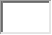- 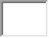- 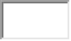 | Request Date:
Title: |  |  | Requesting Facility:
*First Name: |  | 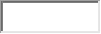 | *Birth Date:
Middle Name: |  | 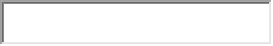 | Birth City:
*Last Name: |  |  | Birth State:
Suffix: |  | 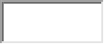 (Jr., Sr.,II, III) | Birth Country:
*Gender: |  | MaleFemale | U.S. Citizen
*Occupation: |  |  | Other Occupation:
Bottom of Form

Preferred Address | BusinessResidence | Secondary Address | BusinessResidence
*Address(1): | 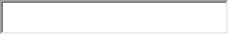 | Address(1):
Address(2): |  | Address(2):
*City: |  | City:
*State: |  | State:
*Zipcode: | 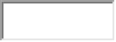 | Zipcode:
*Country: | 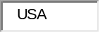 | Country:
*Phone: | 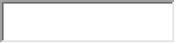 | Phone:
Cell:
Fax: |  | Fax:
*EMail: |  | EMail:

VETPRO REQUIRES AN E-MAIL ADDRESS . ALL ENROLLMENT PACKAGES WILL BE
SENT VIA E-MAIL.

INSTRUCTIONS:
- Request Date: enter the day you are filling out the Enrollment Form
- Facility: enter station/location requesting to hire/federal or contractor/ new or current
- Occupation: enter listed occupation, if not listed select other and go to Other Occupation square
- Other Occupation: enter the occupation not listed in Occupation (example: GS-06 Pharmacy Technician)
- Secondary Address: leave blank if no secondary address
- Email: verify e-mail address is correct
- VetPro Application will be sent to the above e-mail address.

